Elevate your Creativity

[Watch Video](https://www.kingston.com/en/video/play?videoId=uGPjAvlb85maoPrXKarj8ituI2FO1AiOhJscBSiIdj6UzIMQW5GCU0MFTXWiGpwSFDi8gNow-7_ej9lUskJBSg2&start=0&autoPlay=False&chromeless=False&captionOption=No)

SDR2V6

* [Intro](https://www.kingston.com/en/memory-cards/canvas-react-plus-sd-v60#product-features)
* [Product Comparison](https://www.kingston.com/en/memory-cards/canvas-react-plus-sd-v60#comparison-chart-1)
* [Specifications](https://www.kingston.com/en/memory-cards/canvas-react-plus-sd-v60#specifications)
* [Resources](https://www.kingston.com/en/memory-cards/canvas-react-plus-sd-v60#links)
* [Datasheet](https://www.kingston.com/datasheets/sdr2v6_us.pdf)

[**Buy**](https://www.kingston.com/en/memory-cards/canvas-react-plus-sd-v60#atc)

Canvas React Plus V60 SD Memory Cardfor 4K Professional UHS-II Cameras

Kingston’s Canvas React Plus SD card is tailor-made for entry-level UHS-II photography enthusiasts, providing impressive performance that complements standard UHS-II cameras used by budding creatives capturing 4K at higher frames per second (fps) than UHS-I. The card boasts U3 and V60 speed classes with transfer speeds up to 280MB/s1 and capacities up to 1TB2. Say goodbye to sluggish speeds and dropped frames, ensuring a seamless creative process that enhances workflow and efficiency.

* High-performance UHS-II standard
* Ultimate speeds to support professional camera use
* Large storage capacities for digital content library

Key Features



High-performance UHS-II standard

High-performance UHS-II Speed Class 3 (U3) and Video Speed Class 60 (V60) standard for reliable high-resolution photography and video recording.



Ultimate speeds

Speeds up to 280MB/s1 designed to meet the demands of professional camera usage.



Large storage capacities

Large storage capacities up to 1TB2 to store your digital content library.

Compare SD Cards

SDS2

SDG3

SDR2

SDR2V6

SDIT











Name

Canvas Select Plus

Canvas Go! Plus

Canvas React Plus SD

Canvas React Plus V60 SD

Industrial SD

User

Consumer

Consumer-Enthusiast

Professional

Professional

Business/ Industrial

Capacity

64GB-512GB

64GB - 1TB

32GB-256GB

128GB-1TB

8GB-64GB

Speed

• 100MB/s Read (64GB)  
• 100MB/s Read, 85MB/s Write (128GB-512GB)

• 170MB/s Read, 70MB/s Write (64GB)  
• 170MB/s Read, 90MB/s Write (128GB-1TB)

300MB/s Read, 260MB/s Write

• 280MB/s Read, 100MB/s Write (128GB)  
• 280MB/s Read, 150MB/s Write (256GB-1TB)

Up to 100MB/s Read, 80MB/s Write

Compatibility

Yes

UHS-I, U3, V30

UHS-II, U3, V90

UHS-II, U3, V60

UHS-I Speed Class U3, V30, A1

Usage

• Point and shoot cameras  
• Full HD videos

for shooting 4K UHD video and burst-mode photography

• 8K/3D/VR Video Production  
• UHS-II Cinema Cameras  
• DSLR

• 4K Video  
• UHS-II Cinema Cameras  
• DSLR

• Designed and tested to be durable in extreme temperatures

[Learn more](https://www.kingston.com/en/memory-cards/canvas-select-plus-sd-card)

[Learn more](https://www.kingston.com/en/memory-cards/canvas-go-plus-sd-card)

[Learn more](https://www.kingston.com/en/memory-cards/canvas-react-plus-sd-card)

[Learn more](https://www.kingston.com/en/memory-cards/canvas-react-plus-sd-v60)

[Learn more](https://www.kingston.com/en/memory-cards/industrial-grade-sd-uhs-i-u3)

 Reset Chart

 Remove

 Remove

 Remove

 Remove

 Remove

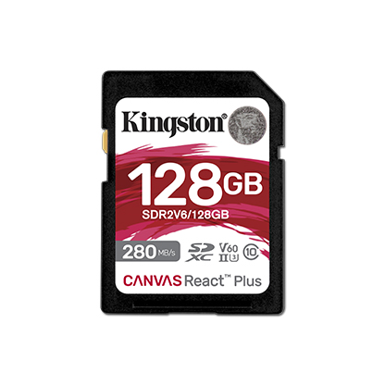

* [Canvas React Plus V60 SD](javascript:void(0))
* [Canvas React Plus V60 SD](javascript:void(0))
* [Canvas React Plus V60 SD](javascript:void(0))

Capacity

 128GB

 256GB

 512GB

 1TB

* Part Number: SDR2V6/128GB
* UHS-II Video Speed Class (V60)
* 280MB/s Read, Up to 100MB/s Write

[**Where to Buy**](https://www.kingston.com/en/wheretobuy)